**Module Federation Plugin**

**Module Federation Plugin : is an advanced feature in webpack that provides a way for a javascript application to dynamically load code from another application**

* **Implement Module Federation Plugin**

1. **Designate on app as the host “ container “ and one as Remote “ Products “**
2. **In remote decide which module you want to make available to other Projects**
3. **Setup Module Federation Plugin to export those files**
4. **In Host decide which files you want to get from remote**
5. **Setup module federation plugin to fetch those files**
6. **In host refactor the entry point to load asynchronously**
7. **In host import files you need from the remote**

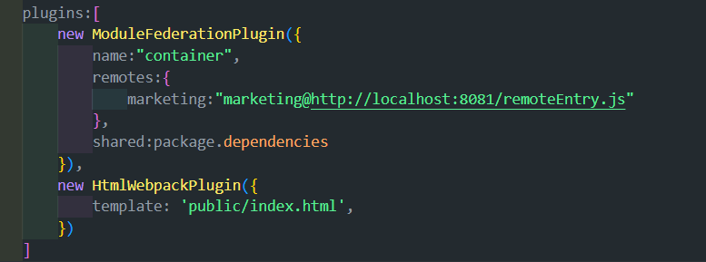

**In module Federation Plugin object**

**RemoteEntry.js : Contains a list of files that are available from this project + directions on how to load them**

**Src_index.js : version of src/index.js that can be safely loaded into the browser**

**Faker.js : version of faker ( lib imported from node_modules ) that can be safely loaded into the browser**

**Module Federations Options :**

* **Name : not used added for clarity only needed for remotes**
* **Remotes : lists projects that container can search to get additional code**
* **Marketing : kiad the file at the listed url if anything in container has an import like import example from “marketing “**
* **marketing@ : related to the ‘’name” property in the marketing webpack config file**
* **http://localhost:8081/remoteEntry.js : url for the remoteEntry File**

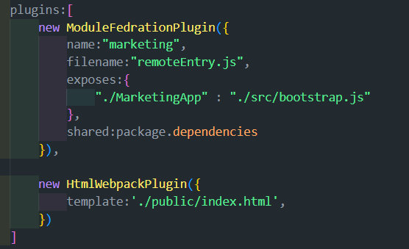

**Module Federations Options :**

* **filename : sets the name of the manifest file**
* **exposes : Aliases file names**